Chapter 16, Solution 33.

Using Fig. 16.56, design a problem to help other students to better understand how to use Thevenin’s theorem (in the s-domain) to aid in circuit analysis.

Although there are many ways to solve this problem, this is an example based on the same kind of problem asked in the third edition.

Problem

Use Thevenin’s theorem to determine v_{o}(t), t>0 in the circuit of Fig. 16.56.

1Ω 1H
+
_
+
0.25 F
10e^{-2t} u(t) V v_{o}
2Ω
–

Figure 16.56 For Prob. 16.33.

Solution

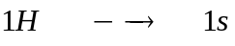 and i_{L}(0) = 0 (the sources is zero for all t<0).
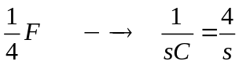 and v_{C}(0) = 0 (again, there are no source contributions for all t<0).

To find Z_{Th} , consider the circuit below.
1 s

Z_{Th}
2

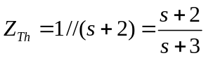
To find V_{Th}, consider the circuit below.

1 s
+
_
+

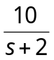 V_{Th} 2
-

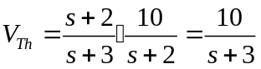
The Thevenin equivalent circuit is shown below

Z_{Th}
+
_
+

4/s V_{o}
V_{Th}

–

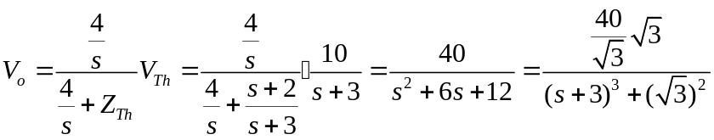.

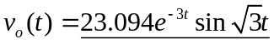V

